Meet Shannon Hayes

THE RADICAL HOMEMAKER
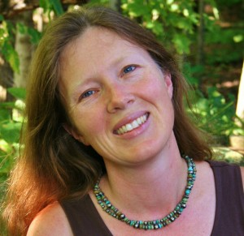
I GREW UP ON SAP BUSH HOLLOW FARM, and in 1999, after getting engaged, Bob and I bought a sunny little cabin 7 miles up the road. It was the biggest move of my life. The cabin blossomed into a solar home where Bob and I produce handcrafts and school our two daughters while working on the farm with my mom and dad. I also write.
I hold a bachelors degree in creative writing from Binghamton University, and a masters and Ph.D. in sustainable agriculture and community development from Cornell. My essays and articles have appeared in myriad regional and national publications, including The New York Times, The Boston Review, and Northeast Public Radio. My quirky lifestyle, my (admittedly imperfect) attempts to live a life of personal accountability and sustainability, and my research and writings about homemaking as an ecological movement have landed me and my family on the pages of the New York Times, Brain Child Magazine, U.S. News and World Report, Lancaster Farming, Small Farm Quarterly, Hobby Farm Home Magazine, The New York Times Magazine, The Atlantic, National Public Radio, Grit, Yes! Magazine, Elle Magazine, Juno, the national newspapers of Germany, Turkey and Canada, the Arab News and the Pakistan Observer.
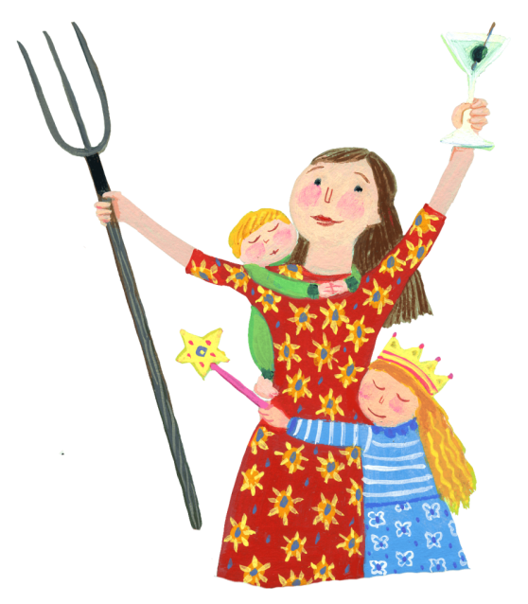
I’ve written six books: The Grassfed Gourmet, The Farmer and the Grill, Radical Homemakers, Long Way on a Little, Cooking Grassfed Beef, and, most recently, Homespun Mom Comes Unraveled. They are available for sale here, as well as through most conventional channels.
From May through Mid-December, I write weekly essays that appear here on this blog, as well as through Yes! Magazine. During the winter I hibernate and work on my book manuscripts. I have a long list of writing projects to fill those months. At the top right now is my first novel, Angels and Stones (almost done…I think!); as well as a non-fiction project – Radical Pleasure: Unleashing Faith, Hope, Healing and Resilience in Hard Times.

